Tab 1

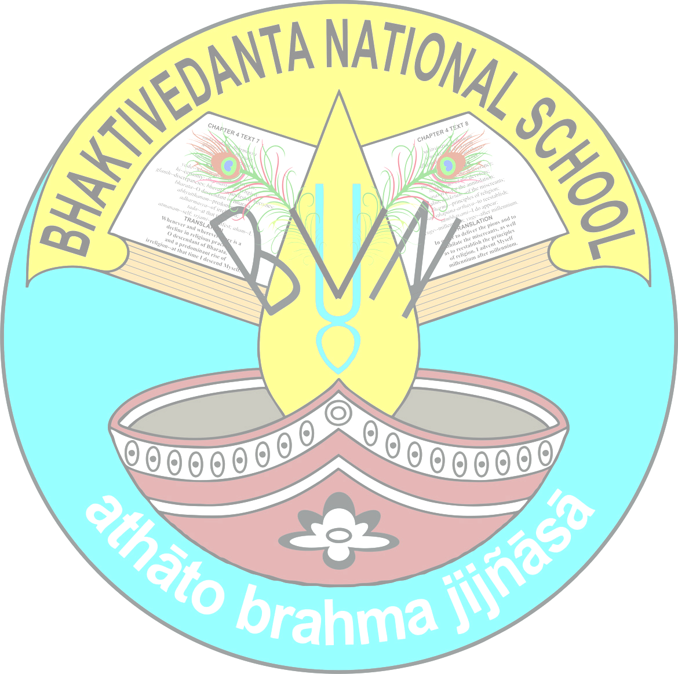

BHAKTIVEDANTA NATIONAL SCHOOL
SRI MAYAPUR, NADIA, 741313
2026-27
STD - IV

SUBJECT: ENGLISH LANGUAGE
EXAM | BOOK NAME: Mastering Grammar | PROJECT/ACTIVITY
EXAM | CHAPTER NUMBER AND NAME | PROJECT/ACTIVITY
Pre mid /CT1 | Ch-1 The sentence, ch-2 Subject and predicate, ch-3 kinds of sentences, ch-4 Interrogative sentences, ch-5 Negative sentences, ch-6 Nouns, ch-7 kinds of nouns + ch-27 comprehension, ch-28 paragraph writing | Chart on sentence
Mid Term/CT2 | Ch-8 nouns: number, ch-9 nouns: gender, ch-10 nouns: possession, ch-11 adjectives, ch-12 articles: a, an, the , ch-13 pronouns, ch-14 verbs, ch-15 verbs: singular and plural ch-29 writing a letter, ch-27 comprehension+ ch-2,ch-6 | Project on verbs
Post Mid Term/CT3 | Ch-16 Present,past and future tense, ch-17 simple present tense, ch-18 present continuous tense, ch-19 simple past tense ,ch-20 simple future tense , ch-31 writing stories , ch-27 comprehension | Activity on Tense
Annual/CT4 | Ch-21 adverbs, ch-22 prepositions, ch-23 conjunctions, ch-24 interjections, ch-26 punctuation and capital letters , ch-26 understanding words better , ch-27 comprehension , ch-30 writing essays +ch-3,8,10,16,17 | Chart on prepositions

SUBJECT: ENGLISH LIT
EXAM | BOOK NAME: The English Treasure + Black Beauty | PROJECT/ACTIVITY
EXAM | CHAPTER NUMBER AND NAME | PROJECT/ACTIVITY
Pre Mid/CT1 | The English Treasure  Ch-1(I Wish),2(Nanabozho and the Wild Geese),3(David and Goliath),4(What become of them)  Black Beauty  Ch-1(My Early Years),2(Joe Green) | Activity:  Write a small story about a life of horse.
Mid Term/CT2 | The English Treasure  Ch-6(The Nightingale),7(The Candyman),8(The Thief's Story),9(Song for a Beetle in a Goldfish Bowl),10(Tenali Raman and the thieves)  Black Beauty  Ch-3(The Whip),4(Earlshall and Reuben Smith),5(A job horse and Jerry Barker) | Project:  Make a paper mask and tell any three importance of paper mask in english literature.
Post Mid Term/CT3 | The English Treasure  Ch-11(In the land of Lilliputs),12(Come little leaves),14(Friends Forever)  Black Beauty  Ch-6(Poor Ginger),7(Jerry’s New Year) | Activity:  News paper reading and treasure hunt.
Annual/CT4 | The English Treasure  Ch-15(The Watchmaker’s shop),16(How the elephant got its trunk),4(What become of them),10(Tenali Raman and the thieves),11(In the land of Lilliputs)  Black Beauty  Ch-8(Hard Times),9(The good gentlemen and his grandson),10(My last home) | Activity:  Listen and write (Topic will be given in the classroom)

SUBJECT – MATHEMATICS
EXAM | BOOK NAME:New Joyful Mathematics+ Maths Mela Workbook | PROJECT/ACTIVITY
EXAM | CHAPTER NUMBER AND NAME | PROJECT/ACTIVITY
Pre Mid/CT1 | New Joyful Mathematics:  Ch 1 : Large Numbers  Ch 2 : Addition & Subtraction  Ch 3 : Multiplication  Ch 8 : Geometry (Page 150 - 153)  Maths Mela Workbook:  Ch 1 to Ch 3 | 1. Activity: Active Math - Use physical activity to reinforce times tables, such as having students jump or bounce a ball while counting by multiples (e.g., 3, 6, 9...).
Mid Term/CT2 | New Joyful Mathematics:  Ch 4 : Division  Ch 5 : Factors & Multiples  Ch 6 : Fractions  Ch 7 : Decimals  Ch 8 : Geometry (Page 154 - 160)  &  Ch 2 : Addition & Subtraction  Ch 3 : Multiplication  Maths Mela Workbook:  Ch 4 to Ch 7 | 1. Activity: Fraction Pizza/Shapes - Students create a pizza or shape on paper, then divide it into parts (halves, quarters, eighths) to identify proper and equivalent fractions.
Post Mid /CT3 | "New Joyful Mathematics:  Ch 9 : Symmetry  Ch 10 : Measurements  Ch 11 : Perimeter & Area  Ch 8 : Geometry (Page 160 -163)  Maths Mela Workbook:  Ch 8 to Ch 10” | 1. Activity: Inkblot Patterns - Place paint droplets on one side of a paper, fold it in half, press down, and unfold to create a symmetrical, abstract design.
Annual/CT4 | Ch- "New Joyful Mathematics:  Ch 12 : Time  Ch 13 : Money & Unitary Method  Ch 14 : Data Handling  Ch 8 : Geometry (Page 164 - 169)  &  Ch 3 : Multiplication  Ch 4 : Division  Ch 6 : Fractions  Ch 11 : Perimeter & Area  Maths Mela Workbook:  Ch 11 to Ch 14" | "1. Activity: Classroom Market/Sale - Students bring items to ""sell,"" creating a store where peers buy and sell items using play money, practicing calculation, and preparing bills.”

SUBJECT – SCIENCE
EXAM | BOOK NAME: Let's explore science | PROJECT/ACTIVITY
EXAM | CHAPTER NUMBER AND NAME | PROJECT/ACTIVITY
Pre Mid /CT1 | Ch-1: Food our basic need  Ch- 3 : Clothes we wear  Ch-5: Safety and first AIDS  Ch-6: Green plants | - First aid box class chart on road safety signs  - Identifying plants and their parts with live examples.
Mid Term /CT2 | Ch-2: Teeth and digestion of food.  Ch-4: Matters and its states.  Ch-7 : Adaptations in plants.  - Ch-1 and ch-6 from pre mid term. | Make a model on teeth structure.
Post Mid Term/ CT3 | Ch-5: Solar system  Ch- 8: Animals and their baby  Ch-11: Weather, air and water. | - Solar model
Annual/CT4 | Ch- 9: Adaptations in animals.  Ch- 10: Force , work and energy.  Ch-12: Pollution of the environment.  - Ch- 8 and ch- 11 from postmid term. | Role play on force work and energy.

SUBJECT: SST
EXAM | BOOK NAME: My Big Book Of Social Studies | PROJECT/ACTIVITY
EXAM | CHAPTER NUMBER AND NAME | PROJECT/ACTIVITY
Pre Mid | Ch -1 (I love My India)  Ch-2(The Northern Mountains)  Ch-3 (The Northern and Coastal Plains)  Ch-4 (The Western Desert)  Ch-5 (The Southern Plateaus and The Islands) | • Draw India's map and mark:  - Northern Mountains (Himalayas)  - Northern Plains (Indo-Gangetic Plains)  - Coastal Plains (e.g., Malabar, Coromandel)  - Western Desert (Thar Desert)  - Southern Plateaus (Deccan Plateau)  - Islands (Andaman Nicobar)
Mid Term | Ch- 6 (Our Climate)  Ch-7 (Our Soils)  Ch-8 (Our Agriculture)  Ch-9 (Our Industries)  Ch-10 (Our Transport and Communication) +  Ch-1 (I Love My India)  Ch-3 (The Northern and Coastal Plains) | •State Profile:  - Choose a state (e.g., Punjab).  - Make a poster on:  - Climate  - Main soils  - Key crops  - Important industries  - Transport links
Post Mid Term | Ch-11(Our Natural Resources)  Ch-12(Our Forests)  Ch-13(Our Water Resources)  Ch-14(Our Mineral Resources) | •Create a poster on saving resources.
Annual | Ch-15(they ruled India)  Ch-16(the age of exploration)  Ch-17(our rich culture)  Ch-18(our rights and duties)  Ch-19(local self government in cities) +  Ch-11(Our Natural Resources)  Ch-12(Our Forests) | •Our Rich Culture:  - i)Festival Collage  - ii)Traditional Dresses:  Draw and label attire from different states.

SUBJECT- MUSIC
EXAM | BOOK NAME: Bhakti giti Sanchayon | PROJECT / ACTIVITY
 | CHAPTER NUMBER AND NAME:
TERM 1 | saḿsāra-dāvānala  Jaya radhe jaya Krishna | Draw Flute
TERM 2 | Radha Krishna prana mora  Parama karuna | Draw mridangam

SUBJECT: HINDI
EXAM | BOOK NAME: वाटिका, व्याकरण भारती | PROJECT/ACTIVITY
EXAM | CHAPTER NAME AND NUMBER | PROJECT/ACTIVITY
Pre Mid/CT1 | वाटिका 1.कौन, 2. कोई किसी से काम नहीं, 3. मुल्ला नसरुद्दीन की चतुराई  व्याकरण भारती 1. हमारी भाषा, 2. वर्ण और वर्णमाला, 3. संयुक्ताक्षर  संवाद लेखन | विभिन्न प्रकार के पेड़ों पर एक सुंदर और जानकारी पूर्ण चार्ट प्रस्तुत करेंगे।
Mid Term/CT2 | वाटिका 4. बादलों के घेरे, 5. हम कुछ सीखें, 6. काकी के दांत, 7. बेटी के नाम, 8. श्रम का मोल  व्याकरण भारती 4. संज्ञा-*लिंग ,*वचन, 5. सर्वनाम, 6. विशेषण  पत्र लेखन, अनुच्छेद लेखन, संवाद लेखन, चित्र वर्णन, पठित/ अपठित गद्यांश /पद्यांश | अपने मित्र को रोचक तरीके से एक पत्र लिखेंगे।
Post Mid Term/CT3 | वाटिका 9. कोयल, 10. ईमानदारी की पौध, 11. दो बैलों की कथा  व्याकरण भारती 7. क्रिया, काल , 8. विराम चिह्न  पत्र लेखन | विराम चिह्नों के ऊपर एक चार्ट प्रस्तुत करेंगे ।(उदाहरण सहित)
Annual/CT4 | वाटिका 12. भारत कोकिला, 13. स्वच्छ बनाएं भारत सारा, 14.आमने- सामने, 15. सपनों की उड़ान, 16. पॉलिथीन का रैपर  व्याकरण भारती 9. शब्द भंडार-पर्यायवाची शब्द, विलोम शब्द, अनेक शब्दों के लिए एक शब्द, अनेकार्थी शब्द, श्रुतिसम भिन्नार्थक शब्द, समूहवाची शब्द  पत्र लेखन, अनुच्छेद लेखन, संवाद लेखन, चित्र वर्णन, पठित/ अपठित गद्यांश /पद्यांश  .10.मुहावरे, 11.गिनती | घर में बेकार पड़े हुए सामानों से कलाकारी करेंगे।

SUBJECT: BENGALI
EXAM | BOOK NAME: পাঠমালা, ব্যাকরণ দর্পণ | PROJECT/ACTIVITY
EXAM | CHAPTER NUMBER AND NAME | PROJECT/ACTIVITY
PRE MID/CT1 | Ch-পাঠমালা – ১.ভুবন ২.শ্রদ্ধা ও ভক্তি ১৩. পারিব না ১৪.সার্থক জনম।  ব্যাকরণ —- ১.সাধু ও চলিত ভাষা ২.ধ্বনি বর্ণ ,৩. শব্দ, বাক্য, উদ্দেশ্য ও বিধেয়।  বোধ পরীক্ষণ , রচনা — কাগজের প্রয়োজনীয়তা, আমার দেশ । | ধ্বনি ও বর্ণের চার্ট।
Mid Term/CT2 | Ch-পাঠমালা –৩. খোদার দরবার ৪.পাশ - ফেল, ১৫.প্রার্থনা, ১৭. দেবতার ঠাঁই.  ব্যাকরণ – ৪. বিশেষ্য ও সর্বনাম পদ ,৫.বচন ও পুরুষ, ৮.ক্রিয়াপদ , ৯.অব্যয় পদ ১০.লিঙ্গ ।  বোধ পরীক্ষণ , চিঠি – পরীক্ষার প্রস্তুতির কথা জানিয়ে বাবাকে পত্র লেখো। + pre mid | কবিতা আবৃত্তি।
Post Mid Term/CT3 | Ch-পাঠমালা – ৬. গিন্নি ৭.পরমপুরুষ শ্রীরামকৃষ্ণ ও নরেন ১৮. বাবুই পাখিরে ডাকি, ১৯.ডানপিটে ।  ব্যাকরণ — ৭. পদ পরিবর্তন ১১.স্বরসন্ধি ১৩.শব্দের বৈচিত্র্য।  বোধ পরীক্ষণ, রচনা – আমাদের জাতীয় পতাকা,  রবীন্দ্রনাথ ঠাকুর। | রিডিং।
Annual/CT4 | Ch-পাঠমালা –৯. অপুর পাঠশালা, ১১.চিড়িয়াখানা ২০.সকল দেশের সেরা, ২৪.সিপাহি বিদ্রোহ।  ব্যাকরণ — ৬. বিশেষণ পদ,১২.কারক সম্বন্ধে ধারণা ,১৪.শুদ্ধ বানান.  বোধ পরীক্ষণ , চিঠি – ইস্কুলে অনুপস্থিতির কারণ জানিয়েছেন শ্রেনি শিক্ষিকাকে পত্র লেখো। রচনা – গাছ আমাদের বন্ধু, দেশপ্রেমিক সুভাষচন্দ্র বসু। + Post mid | বানান পরীক্ষা।

SUBJECT- SANSKRIT
EXAM | BOOK NAME: समर्थ संस्कृतम्-2 | PROJECT/ACTIVITY
EXAM | CHAPTER NUMBER AND NAME | PROJECT/ACTIVITY
Pre Mid | Pg- 6(वर्णमाला), 8 to 9(पुनर्नवा-1), 12(पुनर्नवा -२), 13 to 16(त्रीणि वचनानि सन्ति), Pg-17( धातुः परिचयः), Ch-1(सूर्यः तपति मेघः वर्षति )। | Chart making or model making on पुनर्नवा-1,2 or धातुः परिचयः ।
Mid Term | Ch- 2(सः पठति ते पठन्ति), 3(एकः नरः चतस्रः चटकाः) 4(गायत इदम् बालकाः पद्यम्) +From Premid (Ch-1) , Pg-6 (वर्णमाला)। | Model on Ch-3(Fruits) or Pg-6(वर्णमाला) etc..
Post Mid Term | 5(शरीरस्य अङ्गानि), Ch- 6(एते कार्यरताः सन्ति ), 8(त्वम् कुतः आगच्छसि) + Pg- 82 to 85 ( धातुव्यवहारः )। | Chart making or model making on Ch-5(Body parts) or ch-6 etc..
Annual | Ch- 7(मम विद्यालयः), 10(एते कर्मकराः सन्ति), 11(एतत् बसस्थानकम् ) + From Postmid- Pg- 82 to 85 ( धातुव्यवहारः )। | Chart making on Ch-10.

SUBJECT: GK
EXAM | BOOK NAME: | PROJECT/ACTIVITY
EXAM | CHAPTER NUMBER AND NAME | PROJECT/ACTIVITY
Pre Mid/CT1 | Ch-1,2,3,11,12,13,20,21,28,29,38,39,40,41 | Symbols of the world (Make a chart)
Mid Term/CT2 | Ch no.-4,5,6,7,14,15,22,23,30,31,32,42,43,44,45,46,52,53,54 | Activity – Make a chart about the importance of plants in the world
Post Mid/CT3 | Ch-8,9,16,17,24,25,47,48,49,58 | Make a chart on Great personalities of India
Annual/CT4 | Ch-10,18,19,26,27,50,51,55,56,57,59 | Chart on patterns of stars
SUBJECT -HPE
EXAM | BOOK NAME: | PROJECT/ACTIVITY
EXAM | CHAPTER NUMBER AND NAME | PROJECT/ACTIVITY
Term 1(PreMid+Mid) | - Football (Boys)  - Kho kho (Girls)  - Drill  - Chess | - Football - Passing, Dribbling, shooting etc.  - kho kho- sitting in squares, diving etc.  - Drill - calisthenics ,dumbbell etc.  - Chess- chess pieces and their movement.
Term 2(Post mid+Annual) | - Badminton.  - March past.  - Cricket. | - Badminton- shuttle run ,shot and high service etc  - March past- Attention, left and right turn  - Cricket- batting, bowling and fielding activity.
SUBJECT – COMPUTER
EXAM | BOOK NAME:Track Pad | PROJECT/ACTIVITY
EXAM | CHAPTER NUMBER AND NAME | PROJECT/ACTIVITY
Pre Mid/CT1 | Ch-1 (Computer memory),Ch-2(Managing files and folders) | Computer Lab  project - Create a folder and a sub folder.Create a MS word file inside the sub folder and save it with your name.
Mid Term/CT2 | Ch-3(Images and objects in word 2021, Ch- 4( Creating Tables in word 2021, Ch-5(Introduction to Power point 2021) | Computer Lab  Project - Prepare a presentation on soil pollution.  Techpractice pg(3,4,5,6)
Post Mid/CT3 | Ch-6(More on PowerPoint 2021),Ch-7(More on Internet). | Computer Lab  Project  Tech practice pg(7,8,9,10)
Annual/CT4 | Ch-7(More on Internet), Ch -8(Visual processing), Ch-9(Blocks in Scratch), Ch -10(Drawing shapes in Scratch),Ch- 11(Categories of Robots). | Computer Project  Collect pictures of different types of AI devices and paste it in a chart paper and write something about it.  Tech practice pg( 11,12,13,14,15)

SUBJECT – SASTRA
EXAM | BOOK NAME: Values of life
 | CHAPTER NUMBER AND NAME: | PROJECT/ACTIVITY
PRE MID | Ch-1 (Does God Exist?)  Ch-2 (Knowledge of the soul)  B.G slokas (1.1,2.7,2.13,2.14)  Brahma Samhita slokas ( 11,12,13)
MID TERM | Ch-3 (A Loving God)  Ch -4 (Positive Attitude)  B.G slokas (2.20,3.14,4.7,4.8)  Brahma Samhita slokas ( 14,15,16)
POST MID TERM | Ch- 5 (Being Polite)  Ch- 6 (Controling Anger)  B.G slokas (4.34, 5.18, 7.19, 8.5)  Brahma Samhita slokas (17,18)
ANNUAL | Ch- 7 (Forgive and Forget)  Ch- 8 (Lessons from Nature)  B.G slokas (9.2,18.65,18.66)  Brahma Samhita Slokas

SUBJECT-ART
EXAM | BOOK NAME:BEGIN WITH ART
 | CHAPTER NUMBER AND NAME | PROJECT/ACTIVITY
Pre Mid/CT1 | Ch-PAGE NUMBER 1TO 8. | JAPANESE MAN
Mid Term/CT2 | Ch-PAGE NUMBER 9TO 18. | CREATIVE PAINTING.
Post Mid/CT3 | Ch-PAGE NUMBER 19 TO 24. | BAT MASK.
Annual/CT4 | Ch-PAGE NUMBER 25 TO 31. | SPRAY PAINTING. PAPER COLLEGE.

SUBJECT: YOGA
EXAM | BOOK NAME:
EXAM | CHAPTER NUMBER AND NAME | PROJECT/ACTIVITY
Term 1(PreMid+Mid) | Ardha chakrasana, Ardha mukho swastikasana,Paschima uttanasana, Naukasana,Vhamori Pranayam | Chart Making
Term 2(Post mid+Annual) | Padahastasana,Matsyasana, Chakrasana,  Satubandhasana | chart making
SUBJECT – DANCE
EXAM | BOOK NAME:
 | CHAPTER NUMBER AND NAME: | PROJECT / ACTIVITY
TERM 1 | Thattadavu  Bhava  Tritaal tihai  Song- ore grihobashi, Radha Krishna pranmor | Bhava
TERM 2 | Nattadavu  Navarasa  Tritaal toda  Song - Poush toder Daak diyeche, Hari bolbo ar modon mohon heribo go. | Navarasa

Tab 2

